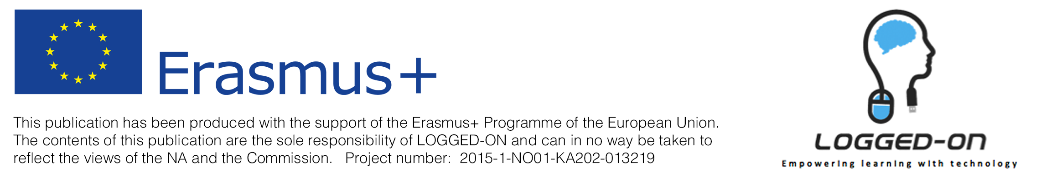

Identification:
School: Scuola Ladina di Fassa
Country: Italy
Version of the document: 1.0

Case study: Wordpress.com as a platform for sharing

Context:
Wordpress.com is a free online platform for creating blogs/websites.
This tool is very useful to make students have an overview on their artistic production during the 5 years of high school, as an online portfolio.
This case study is presented to the last year students of the Liceo Artistico (art school) in both fine arts and design sections.

Implementation in the case-study institution:
To start off with each student had to come up with a concept for the blog, an identity which would reflect the particularities of each student.

During the project students had to:
- come up with a name for the blog
- document works (photograph, scan, post-produce)
- use copyright free material
- organise content and define navigation of blog ( posts, pages, menu, widgets etc..)
- learn how to use wordpress.com using coding in some occasions
- publish their work (optional) and have a world exposure
- manage views and comments

Aims and methods of the case-study:
This activity was developed in CLIL methodology using L2 English during the artistic lab lessons.
The aim is to give the students a tool/container to share their work.

Findings from the case-study:
After an introduction and general guidelines some of the most advanced students carry out the project very autonomously, working well also at home. Other students need more guidance especially on organising ideas but also technicalities of wordpress.

Conclusions:
Most of the students took the blog project as an opportunity to talk about themselves. In general the blog project has been successful and the learners are having fun working on it.

